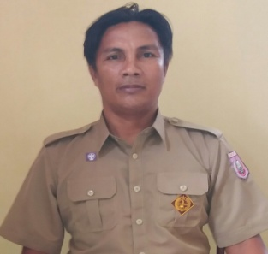

ROSIHAN KALUKU,S.KOM

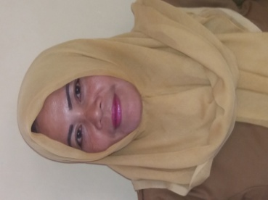

RUNI DINI MUSA

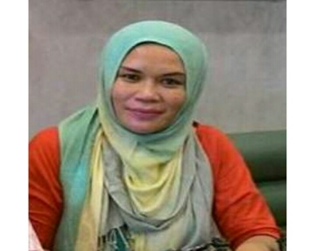

SRIDOLLY M. LANTU,A.Md

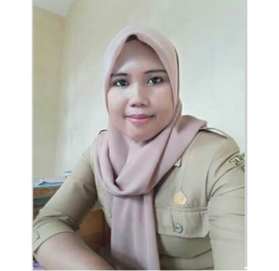

MERY NATALYA JUNUS,S.IP

SARINA HAMDJATI

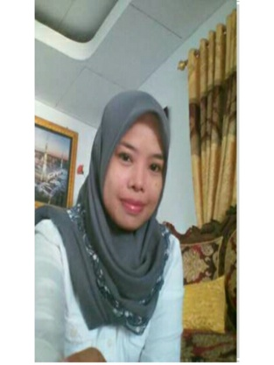

JOLANDA BASARA

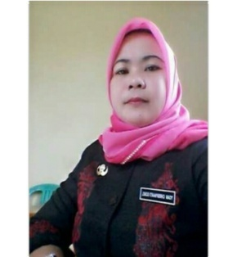

YOAN CHRISFINARTI GOBEL

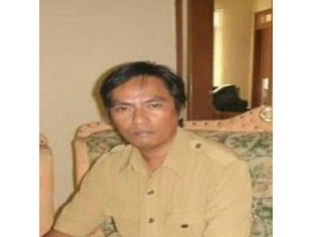

RULLY R. HARUS,S.Sos

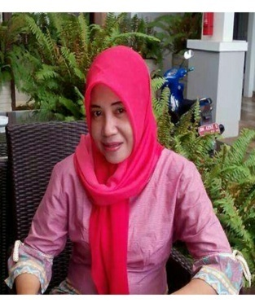
NURMAYA K.ABDULLAH,SE

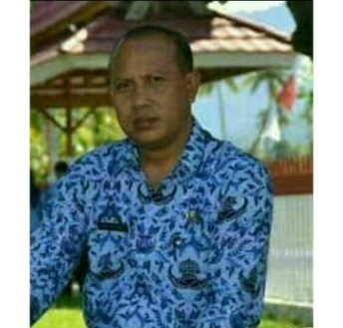

YASIN ENTENGO

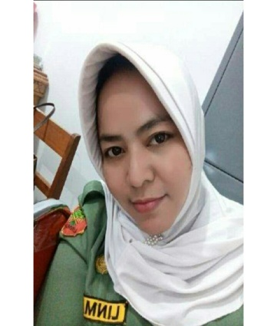

FONNY B.INO,SE

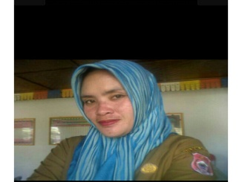

SUSANTI JAHJA

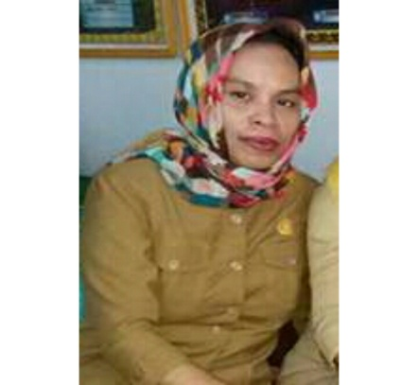

DEVIYANTI KAROLINA SAID,SE

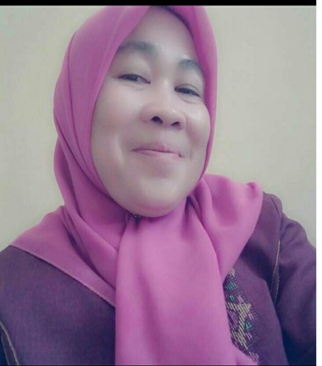

YUSNI HUNTOYUNGO,SM

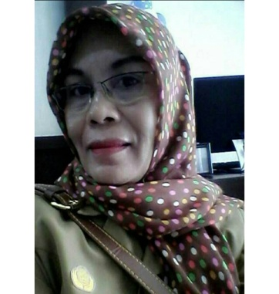

EFLIN S. DOMILI

UDIN KUKU,S.Pd,MM.Pub

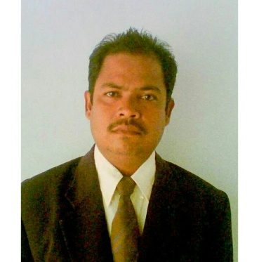

SYOFYAN IBRAHIM,S.IP

WAHYUNINGSIH GANI,SE

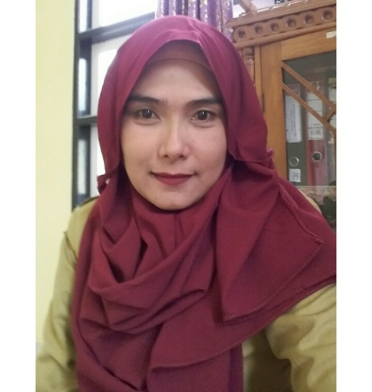

OLVIYANTI DAI,S.AP

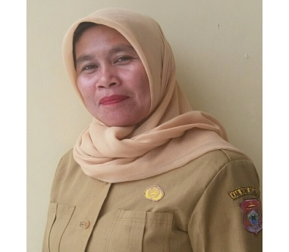

NURHAYATI SUPU

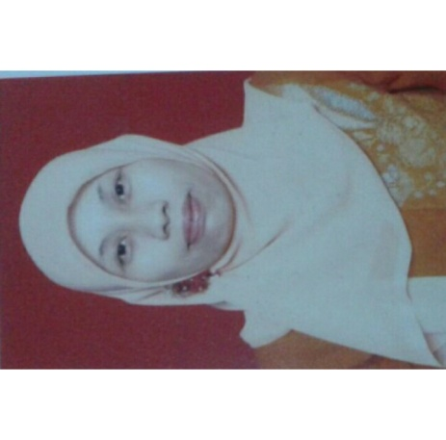

DIANA TUWENO,SE

